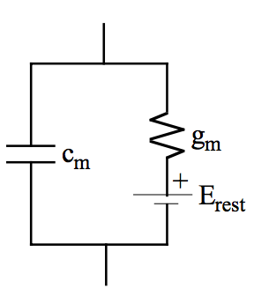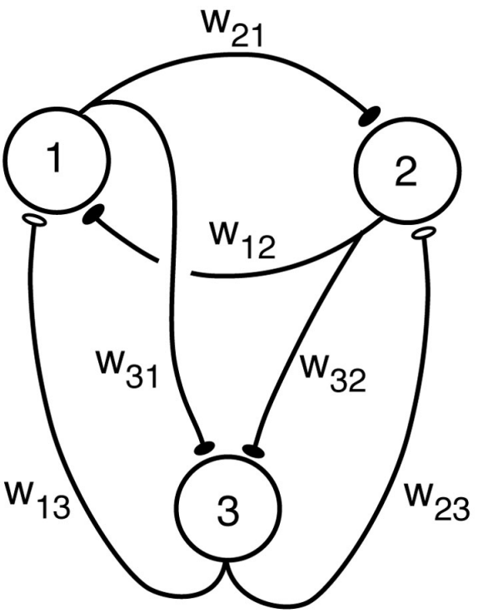

**Hopfield Nets**

$$τ= -S_{i}+F\left[\sum_{i}{w_{ij}x_{j}}\right]$$

Assume Steady State for analysis $→$ discrete steps from $\vec{S}→\vec{S}'$

$F$ can be any fn ($sign()$, for instance)

${\vec{S}}^{'}=\vec{S}$ is a stable state. Patterns are stable states.

For patterns $ξ$:

$${\vec{ξ}}^{j}=\left\{ξ_{1}^{j},…, ξ_{N}^{j}\right\}, j=1→P$$

$$w_{ij}=\frac{1}{N}\sum_{k=1}{ξ_{i}^{k}ξ_{j}^{k}}$$

Where $w_{ii}=\frac{P}{N}; w_{ij}=w_{ji}$

Noisy patterns require more signal than noise for the pattern to be recovered consistently.

**Supervised Learning** (differentiable $s(x)$)

Patterns: ${\vec{u}}^{1},…, {\vec{u}}^{p}$

Desired outputs: ${\vec{v}}^{1},…,{\vec{v}}^{p}$

$$Err\left[\vec{w}\right]=\frac{1}{2}\sum_{p}{{\left( v^{p}-s(\vec{w}∙{\vec{u}}^{p})\right)}^{2}}$$

$$\frac{∂Err}{∂w_{k}}=-\sum_{p}{[v^{p}-s(}\vec{w}∙{\vec{u}}^{p})] \left.\frac{∂s}{∂h}\right| {\overset{⃑}{u}}_{k}^{p}$$

Where $h= \vec{w}∙{\vec{u}}^{p}$

$$∇Err=[\frac{∂Err}{∂w_{1}}, …,\frac{∂Err}{∂w_{k}}]$$

Gradient Descent

$$Δ \vec{w}=-ϵ\vec{∇}Err$$

**Hebbian (unsupervised) Learning**

$$τ\frac{dV}{dt}=-V+\vec{w}∙\vec{u}$$

$$Δ\vec{w}=\frac{1}{τ_{w}}V\vec{u}=\frac{1}{τ_{w}} 〈V\vec{u}〉$$

$${\left\|Δ\vec{w}\right\|}^{2}≈\frac{2}{τ_{w}}V^{2}>0$$

Weights can unboundedly grow… so Oja’s Rule is req’d:

$$Δ\vec{w}=\frac{1}{τ_{w}}[V\vec{u}-V^{2}\vec{w}]$$

**Perceptron $V=s [\vec{w}∙\vec{u} ]$**

$V\left(t→∞\right)=\left\{\begin{aligned} 1, \vec{w}∙\vec{u}≥γ \\ -1, \vec{w}∙\vec{u}<γ\end{aligned}\right.$

Where $u$ is input, and $w$ is weight, and $γ$ is a learned constant

3-layer perceptron can solve any continuous mapping function

4-layer perceptron can solve any mapping

From circuit model shown at left, we require that:

1. Assume that V is the output (no spikes)

2. is linear,

3. , where is a squashing fn, i.e. $s=\frac{1}{1+e^{-x}}$

Solid $→$ Inhibitory

Empty $→$ Excitatory